
Failure to follow post procedure instructions
WILL result in LOSS or DISCOLORATION of pigment.

Please do not hesitate to call is you have ANY questions.


WAIT 24 HOURS before wetting area.

If itching occurs, gently press on the area with a Q-Tip.

It is normal to lose 1/3 of the color during the healing process.
Initially, your color may appear too dark; in six days it may appear too light. After ten days, the color will show more.
When completely healed, it will appear softer.


- Use Retin-A or Glycolic Acid
- Use Peroxide or Neosporin
- Scrub or Pick area of Procedure
- Use Tanning Beds or Lay Out
- Swimming/ Hot Tubs/ Facials (5 Days)
- Dye or Tweeze (1 Week)

Permanent Makeup procedures are affected by the canvas (your skin) that they are performed on. If your skin is sun damaged (even from tanning beds), thick and uneven in texture, or excessively dry or oily the result cannot be expected to be perfect after the initial procedure. Scars on the lips from fever blisters cause pigment removal. Lifestyle, medications, smoking, metabolism. Facial surgery, and/or age of skin all contribute to fading. Your procedure maintenance, as outlined in your pew/post procedure directions, is VERY important.
Additionally, vitamins, water on the area, alcohol intake, non-compliance with post procedure directives, premature exfoliation, manual picking and scab removal, unknowns from previous work/ permanent makeup and/or miscellaneous variables may contribute to color loss. When in doubt, do not disturb the area of the procedure.

Too Dark? No WORRIES!
In about 5 days you will say, “All of my color came off.”
*Warning- it goes through an “Ugly-Stage”*
Color Loss/ Fade Chart
**+/- depending on client variables**
Tattoo Brows 20-30%
Powder Brows 40-50%
Eye Liners 20-30%
Lips-(Kolorsource ink) 70-80%

Lips (OPM ink) 50% */-

Note to client: This is NOT a tattoo, it is micro- insertion which is a form of a tattoo.
Please give the procedure area the time and attention it needs to heal properly, and produce the results applied for.
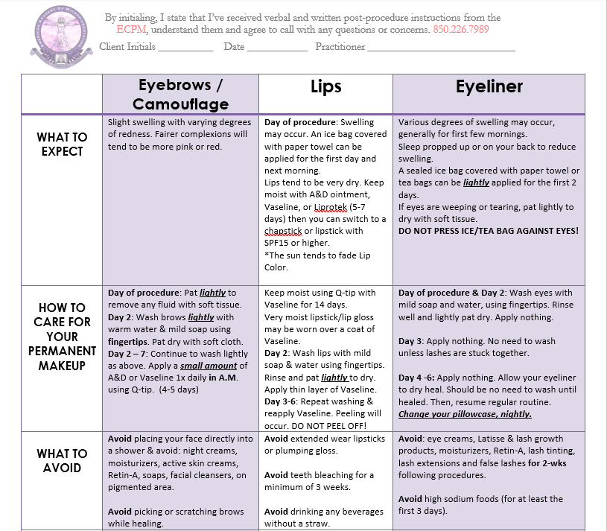

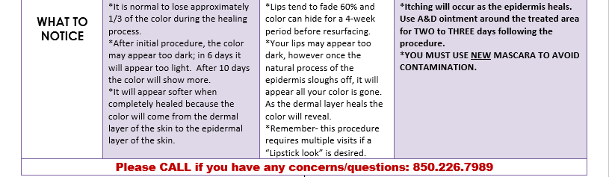

VARIABLES INVOLVED WITH THE OUTCOME OF THE PERMANENT MAKEUP PROCEDURES (RESULTS VARY)

- Skin type i.e.- fair, sensitive, oily
- Sun damaged skin
- Scars
- Smoking
- Medical Conditions
- Vitamins and/or medications taken
- Anesthetic creams used
- Type of Ink
- Following aftercare directions
- Homeopathic treatment
- Type of Procedure performed
- Misc./ other unknowns

THANK YOU FOR YOUR BUSINESS!
***IF YOU ENJOYED YOUR EXPERIENCE WITH US- PLEASE LIKE US ON FACEBOOK AND LEAVE US A REVIEW (IT’S THE HIGHEST FORM OF FLATTERY)***
WE WOULD LIKE TO GIVE YOU SOME STORE CREDITS
HOW?

- PURCHASE ANOTHER SERVICE AND RECIEVE A COMPLIMENTARY TOUCH-UP
OR
RECEIVE A 2ND APPLICATION FOR 50% OFF!

- REFER A FRIEND AND RECEIVE $50-$100 STORE CREDIT
******OR A VISA GIFT CARD FOR $20******

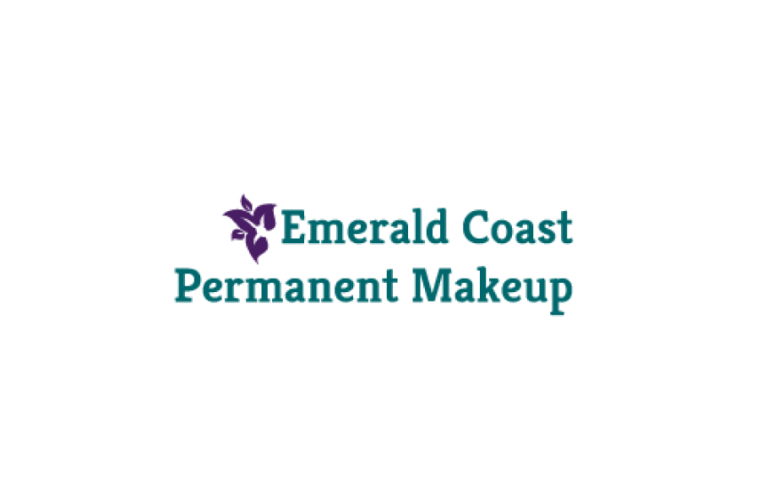

204 Miracle Strip Pkwy SE
Fort Walton Beach, FL 32548
ECPMakeup@gmail.com
850.226.7989
EmeraldCoastPermanentMakeup.com

To our valued clients,
A micro-pigmentation and touch-up or perfecting visit may or may not be necessary to achieve the desired outcome. It is recommended to wait at least 30 days after your procedure before receiving a touch-up. Please remember to FOLLOW/READ all the aftercare instructions, we have select clients whose bodies reject the ink or experience other reactions resulting in loss of color. This unlikely circumstance is out of the professional’s control.

Please allow 24 hours notice if a cancellation is needed. The $50.00 deposit is non-refundable and there will be a $25.00 rescheduling fee upon the cancellation of an appointment.

Remember permanent makeup is an art, not a science. With a multitude of variables involved there are no guarantees or refunds. Please contact Emerald Coast Permanent Makeup at 850.226.7989 with any questions or concerns.

Thank you for you patronage and supporting local business!

Respectfully,
ECPM

